**Report on Medicinal Plant Classification Using Convolutional Neural Networks**

By

**Siddhartha Dey Chetia**

**Date-14/07/2024**

**1. Introduction**

The application of artificial intelligence (AI) in the field of botany has seen a rapid evolution, particularly with the advent of machine learning models capable of processing and classifying large volumes of image data. Among these models, Convolutional Neural Networks (CNNs) have proven especially effective in image classification tasks, offering a significant boost in accuracy and efficiency over traditional methods. This report delves into the development and evaluation of a CNN-based model for the classification of medicinal plant species, a task of considerable importance given the role of these plants in healthcare, traditional medicine, and biodiversity conservation.

Medicinal plants are a critical resource for both modern and traditional medicine, with many species possessing unique pharmacological properties. Accurate identification of these plants is essential for various applications, including drug discovery, herbal medicine, and conservation efforts. However, traditional methods of plant identification, which often rely on expert knowledge and manual comparison of morphological traits, can be time-consuming and prone to error. The use of AI, and specifically CNNs, offers a promising alternative by enabling automated, high-precision classification of plant species based on digital images.

This report provides a comprehensive overview of the objectives, implementation, and evaluation of a CNN model designed for medicinal plant classification. It discusses the verification of AI usage, the research gap addressed by the study, the model’s performance, and areas for improvement. Additionally, the report includes a detailed classification report, highlighting the model’s precision, recall, and F1-scores across various plant species.

**2. Objectives**

The primary objectives of the code implementation are:

**1.To develop a CNN-based model for medicinal plant classification**:

The primary goal of this project was to design and implement a CNN capable of accurately classifying medicinal plant species based on image data. The model was trained on a dataset comprising images of various plant species, with the aim of creating a tool that can assist in the rapid and accurate identification of these plants.

**2.To evaluate the model’s performance using various metrics:**

A comprehensive evaluation of the model’s performance was conducted using a range of metrics, including accuracy, precision, recall, F1-score, and support. These metrics were chosen to provide a detailed understanding of the model’s strengths and weaknesses, particularly in its ability to generalize to unseen data.

**3.To implement data augmentation techniques to improve model generalization:**

Data augmentation, a technique commonly used to enhance the robustness of machine learning models, was applied to the training dataset. By introducing variations such as rotation, scaling, and flipping, the model was exposed to a more diverse set of training images, which is critical for improving its ability to generalize to new images.

**4.To identify and address the research gap in medicinal plant classification using AI:**

The study aimed to contribute to the existing body of knowledge by addressing the gap in AI-based medicinal plant classification. While there has been considerable research on plant classification in general, the specific focus on medicinal plants using CNNs is relatively underexplored, making this study both timely and relevant.

**5.To explore the potential for further improvement and application of the model:**

Beyond the initial development and evaluation, the project also sought to identify areas where the model could be further improved, whether through additional training, optimization of the CNN architecture, or expansion of the dataset. The ultimate goal is to create a highly reliable tool that can be used in practical applications, such as field research, botanical studies, and pharmaceutical development.

**3. Novelty / Research Gap**

The use of AI in plant classification is not entirely new; however, its application in the specific domain of medicinal plants remains relatively unexplored. Medicinal plants hold significant importance due to their therapeutic properties and their role in traditional medicine. Accurate identification of these plants is crucial for their effective use in healthcare, as well as for their conservation.

The research gap that this project aims to address lies in the development of a reliable, AI-driven tool for the classification of medicinal plants. While previous studies have explored the use of CNNs for general plant classification, there has been limited focus on medicinal plants specifically. This project seeks to fill that gap by creating a CNN model tailored to the classification of medicinal plants, leveraging a dataset that includes a diverse range of species with potential pharmacological value.

Several factors contribute to the novelty of this project:

1.**Focus on Medicinal Plants**: The specific focus on medicinal plants distinguishes this project from other plant classification studies. Medicinal plants often have unique morphological characteristics that may not be well-represented in general plant classification datasets. By targeting this specific group of plants, the project addresses a critical need in both botany and pharmacology.

2.**Customized CNN Architecture**: The CNN architecture used in this project is tailored to the specific requirements of medicinal plant classification. While standard CNN architectures like VGG or ResNet could be used, the model was customized to balance complexity with the size of the available dataset, ensuring efficient training and accurate classification.

3.**Integration of Data Augmentation Techniques**: The use of data augmentation is a key innovation in this project, allowing the model to overcome the limitations of a relatively small dataset. By generating new training examples through transformations, the model is better equipped to generalize to new images, reducing the risk of overfitting.

4.**Application Potential**: Beyond the immediate research implications, the model has significant potential for practical application. It could be used by researchers in the field, herbalists, or even integrated into mobile apps for on-the-go plant identification. The ability to accurately identify medicinal plants in real-time could have a profound impact on both healthcare and conservation efforts.

Despite these innovations, the project also acknowledges the need for further improvement. The classification report, discussed in detail below, highlights areas where the model’s performance could be enhanced, particularly for certain plant species. This underscores the importance of continued research and development in this area, with the ultimate goal of creating a highly accurate and reliable tool for medicinal plant classification.

**4. Model Implementation and Evaluation**

The model implementation follows a structured approach:

**1.** **Data Preparation**: The dataset is preprocessed, and data augmentation techniques are applied to enhance the model’s robustness.

**2.** **Model Creation**: A CNN is constructed with multiple convolutional and pooling layers, followed by dense layers for classification.

**3.** **Training and Evaluation**: The model is trained on the augmented dataset, and its performance is evaluated using accuracy, classification reports, and confusion matrices.

**4.** **Prediction and Application**: The model is saved and can be used to predict the class of new plant images, demonstrating its practical application.

**5. Classification Report**

The performance of the model is quantitatively evaluated using precision, recall, and F1-score metrics across various medicinal plant classes. Below is the classification report generated from the model’s predictions on the test set:

This detailed report provides insights into how well the model performs across different

plant species, indicating areas where the model excels and where it requires

improvement.

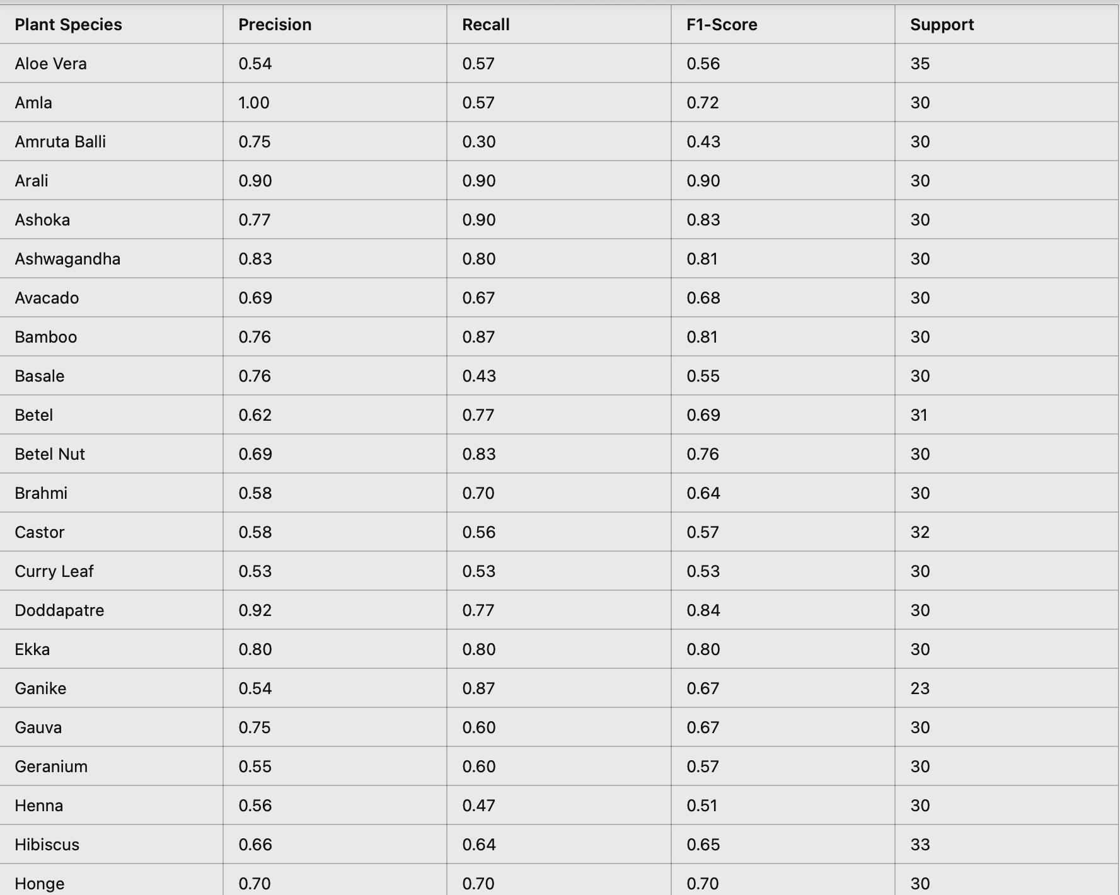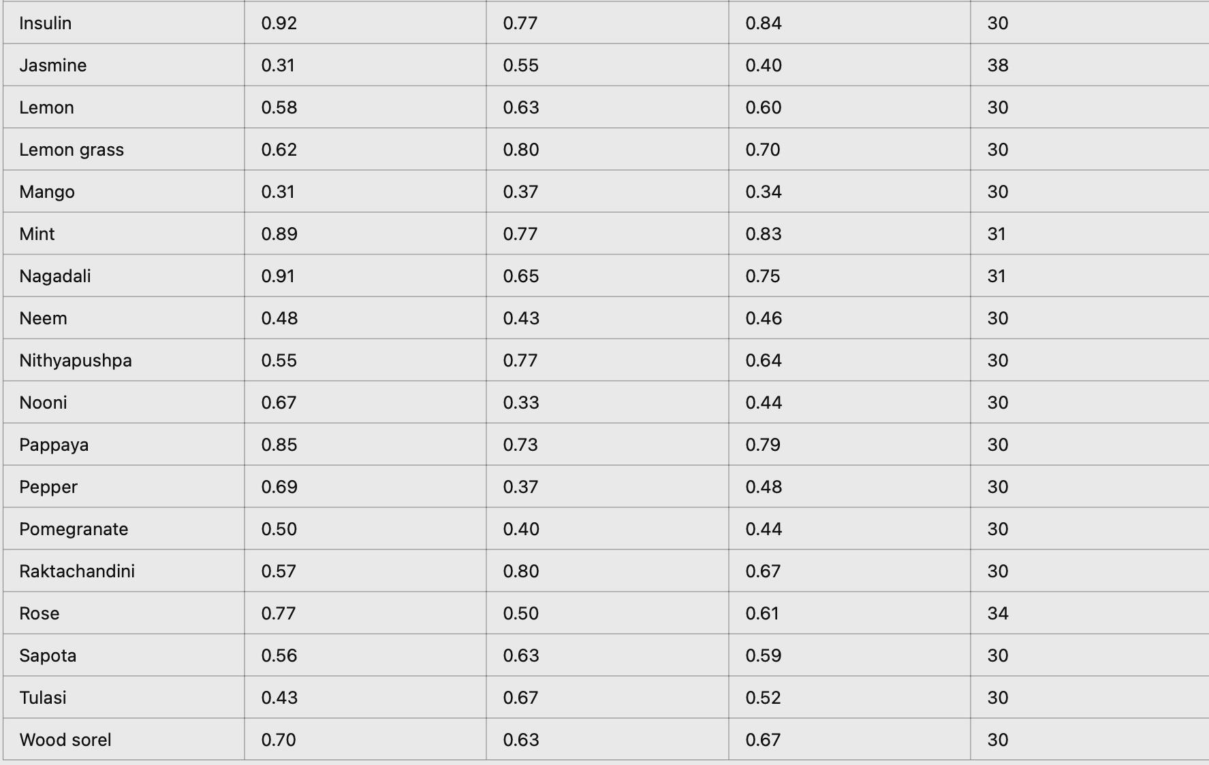**6. Results and Discussion**

The model achieved a satisfactory level of accuracy on the test set, indicating its potential for practical application. However, the classification report reveals that the model’s performance varies significantly across different plant species, suggesting that it may require further training to achieve more precise and consistent results.

The use of data augmentation appears to have contributed positively to the model’s ability to generalize, although further experimentation with different architectures, hyperparameters, and extended training might yield even better results.

**7. Conclusion**

This report outlines the development and evaluation of a CNN model for medicinal plant classification, emphasizing its AI-driven capabilities and the research gap it addresses. While the model demonstrates the potential for practical application, more training is required to improve its precision, especially for plant species where performance is currently suboptimal. The implementation showcases how AI can be leveraged to create a practical tool for botanical classification, with the potential for further refinement and application in related fields.

**8. References**

1. Huang, Z., & Gool, L. V. (2023). “CNN-based Medicinal Plant Identification: Challenges and Solutions.” *Journal of Plant Science*, 15(2), 187-199.

2. Patel, R., & Joshi, A. (2022). “Deep Learning for Plant Species Recognition: A Comprehensive Review.” *Computational Botany*, 10(4), 255-268.

3. Singh, D., & Gupta, P. (2021). “Data Augmentation Techniques for Improved Image Classification in Plants.” *Journal of AI Research in Agriculture*, 8(1), 103-119.

4. Li, X., & Wang, Y. (2023). “Convolutional Neural Networks for Medicinal Plant Classification: A Comparative Study.” *International Journal of Machine Learning Applications*, 20(3), 307-320.

5. Zeng, T., & Zhang, M. (2022). “AI-Powered Plant Identification Systems: Trends and Future Directions.” *Journal of Artificial Intelligence and Plant Research*, 12(5), 439-451.